
Breakthrough or bust: Examining “Dow 20k”
FEBRUARY

On March 29, 1999, the Dow Jones Industrial Average
(the Dow) finished the trading day above 10,000 points for
the first time since the index was first published in 1896. It wouldn’t be until late 2010 until the Dow would (hopefully)
see its last days under 10,000, over 11 years after initially
cracking the five-digit threshold. For the past few months,
the stock market has been hovering around the next big milestone: 20,000. But how monumental of an achievement
is “Dow 20k” for the stock market?
The (in)significance of milestones
The Dow surpassing 20,000 has drawn significant attention
from the media since late 2016, especially given the Dow’s
rapid growth after initially surpassing 19,000 in November. However, not all 1,000-point gains are created equal. From
1896 to 1972, the Dow grew from 40.94 to 1,000, which represented an increase of 2,343 percent. The Dow closing
in the quadruple digits for the first time was indicative of
the index’s massive growth since its inception. The jump
from 19,000 to 20,000 is an increase of only about five percent. Though the timeframe of this increase was incredibly short, the growth itself is fairly unremarkable in the history of the index.
Enduring peaks and valleys
Many investors have a long-term investment strategy.
Though it may be difficult, it is crucial to keep long-term
goals in mind during a bear market or a bull market. For example, in September 1929, the Dow closed around 380,
a record high at the time. Shortly thereafter, the stock market plummeted nearly 90 percent over the next few years in what was the largest economic panic in American history. The Dow wouldn’t return to pre-Depression levels for 25 years. This demonstrates the market’s volatility and reinforces that there
is no guarantee the Dow will stay at or above any threshold.
The impact of “Dow 20k”
It is unclear as to how the 20,000-point milestone will affect
the stock market on a long-term scale. Some investors may
view 20,000 as an indicator of an economy growing too quickly with an imminent slowdown on the horizon. Subsequently,
this could result in a sell-off by bearish investors trying to
time the market. Others may see it as a sign of a strengthening economy with more growth in store, resulting in even
more capital invested in equities. Investors could,
however, consider the milestone arbitrary and could
result in no strong movement in either direction.
Above all the excitement, it’s worth noting that the Dow
is comprised of only 30 stocks. Within the Dow itself, certain stocks are weighted more than others. For example, stock
from Goldman Sachs is weighted about eight times higher
than some of the lowest-weighted stocks within the index.
If one of the top stocks in the Dow, like Goldman Sachs,
sees a large decline, it will drag down the entire index as
a result. Because the Dow is heavily influenced by a few
major companies, it might not accurately portray how
the economy is performing on a larger scale.
The fervor surrounding Dow milestones is likely rooted
in psychology more than anything, as round numbers are appealing to investors because of the perceived significance
of these benchmarks. However, stock market performance
has long been a prominent basis on which investors gauge
their confidence in the economy, and the Dow is arguably the most popular and most referenced index in the United States. Therefore, if investors view the Dow favorably, they might be inclined to invest more capital in the market. Only time will tell how investors will react to the Dow hitting 20,000 and what effect that will have on the index, and the economy, moving forward.

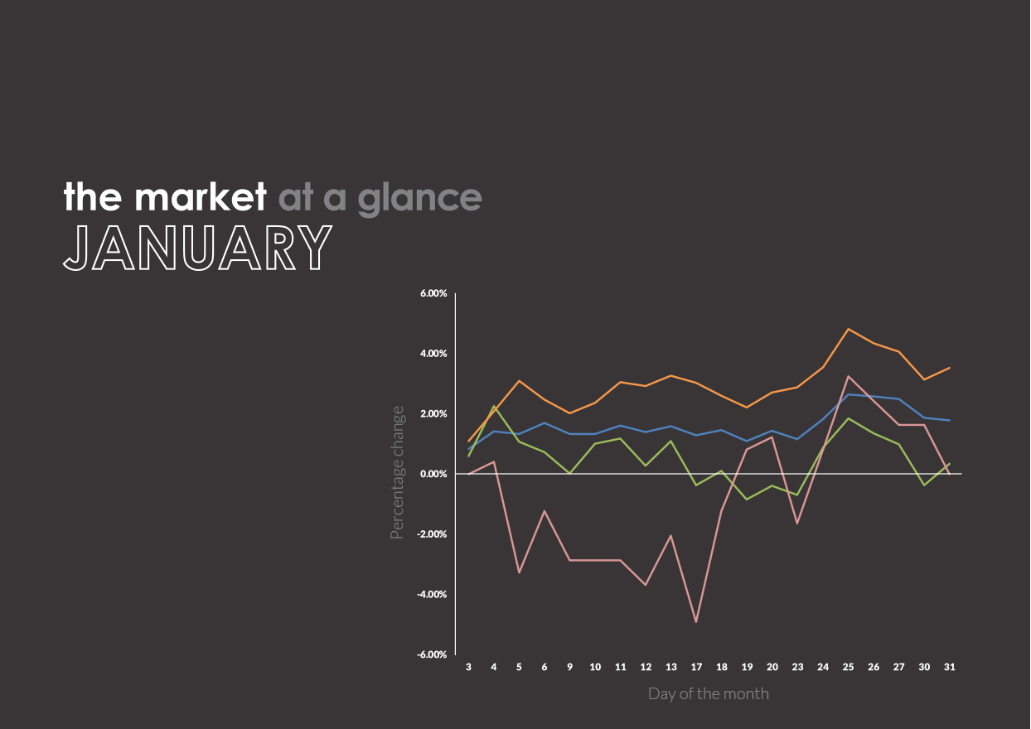



- The Dow Jones Industrial Average reached an intraday high by surpassing 20,000 for the first time
on January 25, coming only 42 trading days after first closing above 19,000. This represented a rapid
gain, as it took the Dow 484 trading days to grow from 18,000 to 19,000. This is the second fastest
thousand-point gain in the history of the Dow, after the increase from 10,000 to 11,000 in spring 1999.
Past performance is no guarantee of future results. Indices are unmanaged and cannot be invested into directly.
U.S. Large Cap
(S&P 500)
2,278.87 (1.79%)
U.S. Mid/Small
(Russell 2000)
1,361.82 (0.35%)
International Large
(NYSE International 100)
5,028.79 (3.54%)
U.S. Treasuries
(U.S. 10-Year Treasury Yield Rate)
2.45 (0.00%)
The market in action
- India intends on completely switching to a country-wide biometric-based payment system by 2020,
according to an address given by government official Amitabh Kant at the World Economic Forum.
The biometric system will use either fingerprint, iris or face recognition for payments. Currently, about
85 percent of the country is registered for the system that will make cash and electronic payments obsolete.
- According to a study by the German reinsurance firm Munich RE, natural disasters caused $175 billion in damage in 2016.
- The U.S. Commerce Department reported that real GDP grew only 1.6 percent in 2016 — its lowest single-year growth since 2011.
- According to figures released by the New York Times, mergers and acquisitions totaled $3.6 trillion last year — which is the third highest single-year total, after only 2015 and 2007.
- A new study from the USDA found that raising a child born in 2015 through the age of 17 will cost an average of $233,610.
- The number of existing US home resales slipped 3 percent in December, falling to its lowest point in over 17 years.
- ABP, the largest pension company in the Netherlands, will not have to cut pensions after last year’s projections indicated a cut was likely in 2017.
- After nearly a century and a half of being the world’s most recognizable circus, Ringling Bros. and Barnum & Bailey will permanently cease all operations in May.

Di-worse-ification?
4 ways your portfolio can become too diversified

There is a saying that diversification is “the only free
lunch in investing.” Since its inception, diversification
has fundamentally changed the way people plan their portfolios and handle investment risk. It has become so central to investing that most retirement accounts sink
all of their value into mutual funds and exchange-traded funds, which feature diversity by their very nature of investing in a pool of assets.
However, just like a different saying, it’s possible
to have too much of a good thing. First coined by
legendary investor Peter Lynch, “diworsification”
is the act of diversifying a portfolio to such an
extent that its returns are damaged.
When diversifying appropriately, you sacrifice some
of your potential for returns in exchange for lower
portfolio risk. But when you over-diversify, you
continue to give up potential returns even though
your risk profile can no longer be significantly lowered. Although diworsification sounds like a problem that
an investor would have to create deliberately, it often occurs in portfolios by accident. Here’s how you can
limit diworsification:
Abandoning old retirement accounts
Much of diworsification stems from account neglect—
like forgetting to roll over a 401(k) when you leave a company—which leads to an inefficient use of your
money. As you slowly move toward your retirement,
your investment should be reevaluated and updated.
Old abandoned account(s) will contain outdated strategies that could be spreading your money among investments that no longer have a place in your investment strategy. Roll over and consolidate retirement accounts whenever
it is possible to do so without paying large fees.

Overlapping mutual funds
Diversity is good, but diversifying multiple accounts individually can lead to useless repetition. When new
(or old) retirement accounts are outside of a coordinated investment strategy, they are often set up to behave like
a miniature portfolio, diversifying among the same type
of mutual funds that are already used in other accounts. This creates a needlessly high level of diversification
within single sectors and can potentially increase the amount you spend on management fees.
Diversifying with weak assets
Diversification should aim to balance a portfolio with
the strategic purchase of quality assets, not simply any investments that move independent or opposite of each other. It can seem like a smart move to balance every dollar you put into a company by putting one into its competitor, giving you diversity that captures the growth of a common industry while reducing risk of a single company failing. But, if one company is clearly better managed and more successful, this kind of diversity will only weigh down your average returns while doing little to lower your exposure to industry risk.
Collecting too many pet stocks or funds
There is no clear number of investments required to
reach “true diversification.” Similarly, there is no
threshold of different investments when a portfolio becomes over-diversified. But you need to keep your
other investments in mind when picking up shares of
pet stocks that have caught your interest. If you find yourself investing in dozens of sector funds or hanging onto scores of individual stocks you lost interest in
years ago, chances are your money is spread thinner
than it needs to be.

What’s the best way to avoid
(or fix) a diworsified portfolio?
Diworsification is not the most serious problem a
portfolio can have, but it does tend to lower returns
and, if applied to a specific sector, can actually lead to overexposure and higher risk. The best way to avoid
being over-diversified is to keep investment accounts consolidated and check that new investments make
a meaningful contribution to your portfolio.
The key to fixing an overly diversified account is recognition of the issue. Gather the account reports
for any outlying or neglected investment accounts
before planning, and be open about your investments
when meeting with your financial advisor. Together,
you can consider each investment’s role within your portfolio and determine whether it can efficiently
work with your overall strategy.

