
By the Numbers:
Recent Grads
June

Last month, millions of Americans received degrees from post-secondary educational institutions and are bound to enter the
workforce. Graduation comes bittersweet for graduates, as this means that the need to being repaying burdensome student loans
is quickly approaching. With college enrollment at an all-time high, student loans increasing at breakneck speed and an increasing emphasis from employers on workers needing post-secondary degrees, let’s examine some statistics about higher education.



40 percent
The percentage of working Americans, aged 25-29, in 2016 who hold at least a bachelor’s degree. 16 years ago, this number sat at just 32 percent.


$50,556
The projected average salary of 2016 graduates, according to the National Association of Colleges and Employers. This represents a 5 percent increase from 2014. ----most recent survey


$37,172
The average amount of student loan debt for a 2016 graduate. Fortunately, this means that, when compared average salary out of school, annual earnings for a recent graduate exceed the average loan amount.

3.9 percent
The unemployment rate of recent graduates. This is less than half of the unemployment rate of workers aged 22-27 who hold less than bachelor’s degree.
44 percent
The relative amount of recent college grads that are underemployed. “Underemployment” is defined as holding a job that does not typically require a post-secondary degree.
226 percent
Amount by which the total number of bachelor degrees issued increased between 1970-1971 and 2014-2015.

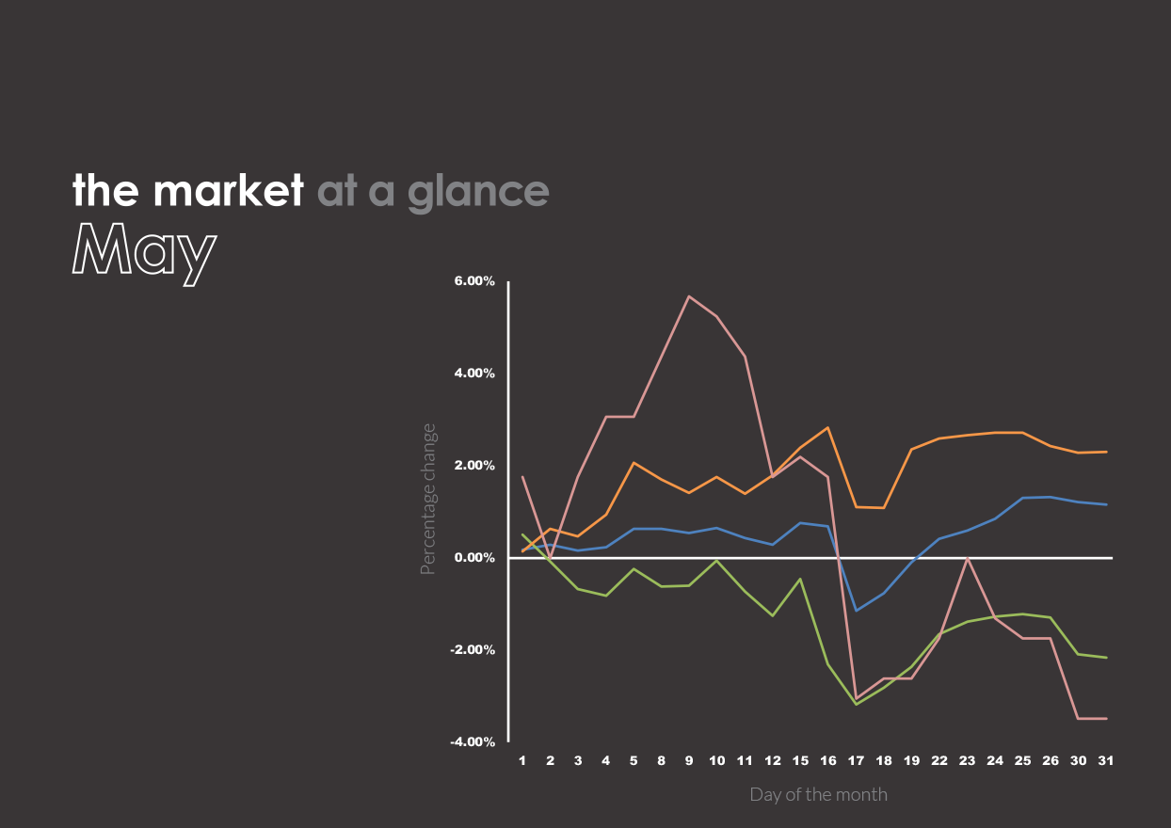




- Household debt in the United States has eclipsed the nominal level of debt at the height of the
mortgage crisis. However, inflation has decreased purchasing power over the past decade,
meaning the relative amount of debt has still not surpassed peak historic levels.
Past performance is no guarantee of future results. Indices are unmanaged and cannot be invested into directly.
U.S. Large Cap
(S&P 500)
2,411.80 (1.16%)
U.S. Mid/Small
(Russell 2000)
1,370.21 (-2.16%)
International Large
(NYSE International 100)
5,316.77 (2.30%)
U.S. Treasuries
(U.S. 10-Year Treasury Yield Rate)
2.21 (-3.49%)
The market in action
- Citing over $70 billion in bond debt and nearly $45 billion in underfunded pensions, Puerto Rico
is seeking the largest government bankruptcy declaration in the history of the United States.
- On the cusp of bankruptcy, Venezuela sold bonds to Goldman Sachs in an attempt to stave off a fiscal
disaster. According to the Wall Street Journal, Goldman Sachs paid about 31 cents for each dollar of bonds.
However, with inflation slated to hit 2,500 percent this year, the effect of this maneuver remains to be seen.
- In a study by Equilar and the Associated Press, the average CEO heading an S&P company made $11.5 million
“in salary, stock and other compensation.” This represented an 8.5 percent increase from the previous year.
- In May, the Volatility Index (VIX), or what is commonly known as
the “fear index,” closed at its lowest level since December 1993.
- According to the New York Times, there are about 32 million children in the
United States who currently receive federal subsidized school lunches.
- Nearly half of Americans cannot afford to cover a $400 emergency, according to information released
by the Federal Reserve’s annual Survey of Household Economics and Decisionmaking.
- Ford Motor Co. plans on cutting around 10 percent of its global workforce, according to the Wall Street Journal.
These cuts coincide with Ford’s intention to cut $3 billion in company costs this calendar year.
- In early May, Apple became the first ever company to have a market cap of over $800 billion.

Retiring Early

It seems as if there has been increasing coverage
in the media recently regarding early retirement.
The prospect of having an extended retirement is
incredibly appealing for many Americans.—However,
with pensions becoming increasingly less common in the workplace, workers are required to be more autonomous
in how they plan for their retirement; for many, the need to bolster self-directed savings makes the prospect of an early retirement seem more like a pipedream than a possibility. Though everyone has varying financial situations and future expectations, here are a few things to keep in
mind when working towards your own early retirement.
Create a current household budget
Before you solidify a plan of action for retiring early,
you need to take inventory of your current expenses
and general spending habits. If your spending habits inhibit you from saving a sizable portion of your earnings in pre-retirement, it will be incredibly difficult to retire early. If possible, try to find ways to cut discretionary expenses and evaluate your saving habits. By developing
a budget, you will put yourself in an advantageous situation. In fact, maintaining a household budget will
put you in the minority of American adults; according
to a Gallup poll, only one in three Americans maintain
a detailed household budget.
Forecast future needs
In addition to considering how inflation will affect
your budget in the future, it will be wise to also consider that certain costs, such as healthcare, will increase significantly in retirement. When calculating your
needs in retirement, be sure to include rising costs and unforeseen expenses. Failure to account for increasing needs could potentially leave you short of cash at a time when you may not be physically fit enough to work the hours required to cover the shortfalls.

Stay disciplined
Cutting out your favorite guilty pleasures in order to save for the future can be difficult, especially when those around you might be going on lavish vacations and buying luxury cars. By saving your money in the meantime and remaining focused on your goal, you will significantly improve the likelihood of being able to retire early.
Consider investing
Though everyone has a different financial situation and tolerance for risk with their money, investing in the stock market has historically produced higher returns over a long timeline than keeping money in a bank. Given low interest rates on most bank accounts, a savings account may not grow your money significantly enough, especially if your retirement plan is predicated on seeing significant growth on your savings. Though investing in the stock market inherently carries risk of potential losses, investing long-term has historically proven beneficial to investors.
Work with your financial professional
In addition to personally taking measures to ensure
an early retirement, remember that your trusted
financial professional is dedicated to working with
you to help achieve your goal. Reach out to your Capitol Private Wealth Group LLC professional to help you work
towards achieving your dream.

