
Smart ways to spend
this school year
September

As children head back to the classrooms this fall, school expenses are on the minds of parents now more than ever. Over the past decade, back-to-school spending has risen significantly and is expected to total more than $27 billion in 2018, according to a recent Deloitte study. While your child dives into their new classes, consider these tips for spending smart this school year.
Timing your costs
The vast majority of back-to-school shopping occurs early,
as 83 percent of total spending takes place before the second
week in August. Yet despite this popularity, holding off until
late August or early September can be a wiser approach.
By waiting to shop for supplies other than the day-one essentials, your student can determine what will actually be needed for each class. This helps avoid purchasing unnecessary supplies or having
to re-shop for missed items. Also, since clothes and accessories typically represent a large portion of back-to-school expenses, waiting allows your child to find out what is in style. On average, early shoppers wind up spending an extra $100 compared to the later shoppers.
Reusing items
Many items can be re-used or handed down to avoid repurchasing. Keep track of durable supplies such as binders, scissors, backpacks, and rulers at the end of each school year so they can be used year after year. For items such as calculators, lab goggles, or other
class-specific needs, try to pass down from brothers, sisters,
or friends who already took the class.
For high school and college students especially, seek out used textbooks to cut down on what is normally a substantial cost.
In addition to the wide variety of online sources, many schools
have an on-campus used textbook system.
Research sales and savings opportunities
Although back-to-school shopping has grown in overall size and cost, so has competition among retailers. This provides consumers with some excellent opportunities to save. Before hitting the
stores, research and compare different retailers’ deals. Often,
the best method is a combination of different stores for different needs. For example, a department store may have the best deals on notebooks and pencils, but a manufacturer may have the best sale on a laptop.
To help with tuition costs, consider using a 529 plan, which is
an investment account designed to give benefits to those saving
for future education. There are two main types of 529 plans: prepaid tuition plans and education savings plans. A prepaid
tuition plan allows for the purchase of college credits at their current price, resulting in savings over time when factoring for inflation. These plans are currently only offered in 10 states
and can get complicated if your student decides to switch schools. These plans are either fully or partially guaranteed by the state governments. Education savings plans, unlike prepaid tuition
plans, can be used at any grade level and for other school-related expenses such as housing and technology. These plans are based
on a range of investment portfolios and may result in added risk while saving for educational expenses.
Do not underestimate the costs
of sports and other activities
Perhaps the most overlooked back-to-school expense does not
take place inside the classroom at all. Research done by Utah State Professor and former NFL player Travis Dorsch indicates that many families are spending upwards of 10.5 percent of their gross yearly income on youth sports alone.
Making a sport and activity budget will help you understand what to expect in this year’s costs. Keep in mind, costs that are less obvious than registration fees – such as travel, equipment, food, and drink – can add up. Look back at previous years’ costs and clarify with your child what they expect to need for this year’s extracurricular calendar.


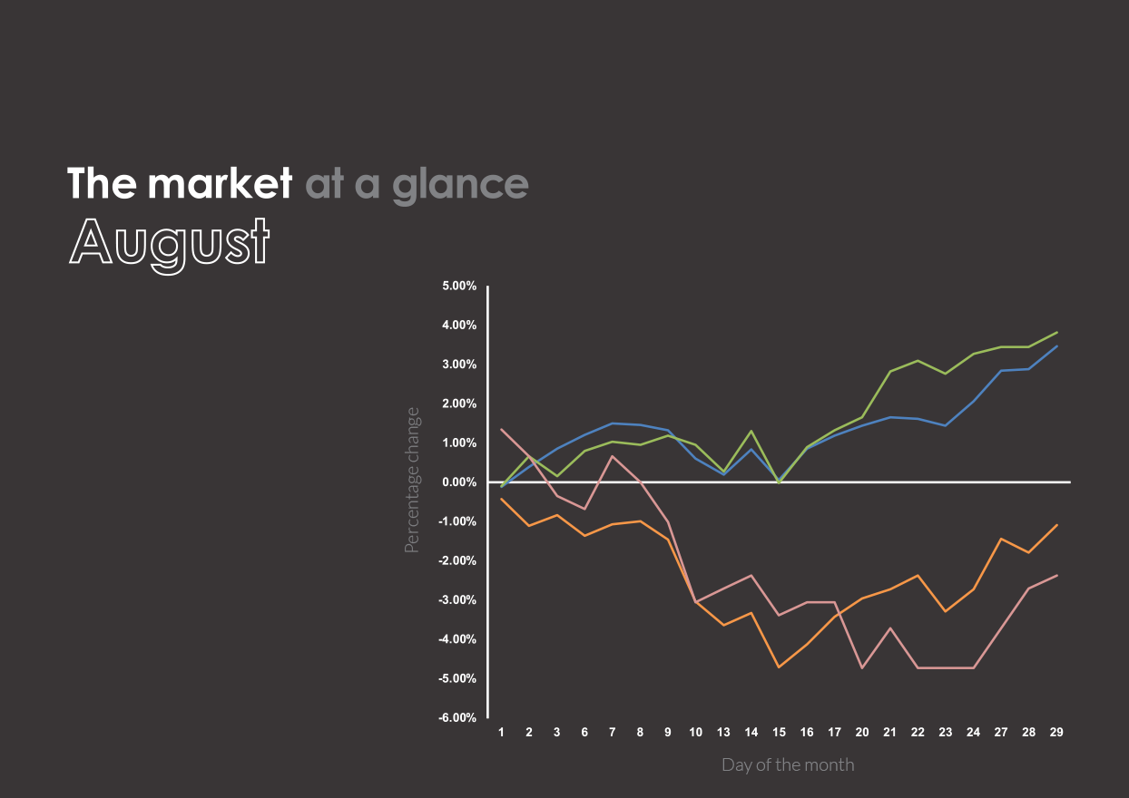


- Electric car and power manufacturer, Tesla, saw volatile changes in stock price following CEO Elon Musk tweeting that he may take the company private. In just minutes, the stock price soared up by $25 per share only to fall downwards through the rest of August amid concerns of production and an SEC investigation.
Past performance is no guarantee of future results. Indices are unmanaged and cannot be invested into directly.
U.S. Large Cap
(S&P 500)
2,901.52 (3.03%)
U.S. Mid/Small
(Russell 2000)
1,740.75 (4.19%)
International Large
(NYSE International 100)
5,552.67 (-2.82%)
U.S. Treasuries
(U.S. 10-year Treasury yield rate)
2.86 (-3.38%)
The market in action
- The U.S. budget deficit in August was 21 percent higher than at the same time last year, while revenues rose only 1 percent. Reductions in corporate tax payments and increased spending on domestic and military programs are primary contributors to the change.
- AT&T employees represented by the Communications Workers of America are rallying around a new analysis of the the telecom giant’s Q2 earnings report, which estimates that the company has eliminated over 7,000 jobs since January. The Q2 earnings report revealed that AT&T has increased its spending on share buybacks to their highest level since 2014.
- Americans’ consumer confidence rose to an 18-year high in August as current economic conditions continued to improve. Consumers are becoming more confident in their ability to get find employment and spend more freely.
- The U.S. and Mexico agreed on a new trade deal, paving the way for a revamped NAFTA. The agreement focuses on areas such as agriculture and automobile production while retaining the ability for American companies to operate in Mexico and Canada without tariffs.

Cost and timing of home remodeling

As with many large purchases, timing matters when remodeling a home. Each season holds advantages for different types of projects based on price and availability. Consider these tips to take advantage of potential savings:
Fall: Pools, kitchens, and appliances
Though pools and summer are tightly linked, waiting until fall for installation can bring worthwhile savings. With the average cost of installing an in-ground pool at $49,224, those savings may be worth the wait.
Kitchen remodeling is among the most popular renovation projects and can be done at any time of the year. Scheduling this project for the fall capitalizes on a slower season for contractors, which can result in lower labor prices. Also,
in terms of convenience, tearing apart the kitchen might be easier once children are back in school. While some kitchen renovations can fall in the $10,000 to $15,000 range, expect closer to the average of $22,530.
Fall can also be an ideal time for purchasing new appliances. In preparation for the holiday shopping season, most manufacturers will introduce their new models in the fall, resulting in sales on previous models.
Winter: Decks, bathrooms, and air conditioning
Ideally, you’ll want a new deck ready to go once the weather warms up but winter is actually the best time to schedule the preliminary planning and design process. This is a dead season for deck contractors and allows your project to be their top priority once the ground softens in the spring. While the cost of building a new deck varies with size,
expect anywhere from $2,000 to $7,000.
Competing with the kitchen for the most popular home renovation is the bathroom. Again, indoor work such as
this can be completed at any time of the year, but lower rates are more likely during contractors’ slow winters. This should make it easier to schedule the contractor and may lead to a quicker completion. Homeowners tend to spend
an average of $10,167 on a new-look bathroom.

While air conditioning is likely the last thought on most consumers’ minds during the winter, this is the time for big savings on both repairs and replacements. Once spring and summer heatwaves kick in, rates will jump back up. The average cost for an A/C repair is $342, while a replacement is $5,465.
Spring: Windows and flooring
Window replacements become common in summer once homeowners start running the A/C, but getting ahead of the curve will help score a deal on installation. Be on the lookout for window companies offering sales to kick off the season and ideally schedule installation once it warms up to over 50 degrees. Prices vary widely based on home size, amount of windows, and type of windows. The average cost for a single-story home with 10 windows is between $3,000 and $7,000.
Late spring is also a great time to pull the trigger on flooring. Early spring can be busy for flooring companies as homeowners begin spending their tax returns, causing tighter scheduling. May is the sweet spot, being right in between this tax-return season and summer’s peak home buying season. Hardwood flooring averages between eight and $10 per square foot with installation while carpeting averages around $3.50 per square foot with installation.
Summer: Paint, landscaping, and furnaces
Demand for almost every renovation project increases during the summer, but there are still deals to be scored. As high school and college students take a break from the classroom, many of them will look towards the popular student painting services for employment. Student-operated painting crews boast substantial savings compared to the labor of professional crews, which should help trim down the $4,000 average cost of an exterior paint job.
Additionally, landscaping and yard work make the most sense to be completed during the summer when the work will be most visible. Though it may be tough to find any deals with the high demand, long summer days allow for more DIY opportunities to cut costs.
Lastly, like air conditioning in the winter, savings can be found on furnace repair and replacement in the summer. Average furnace repair costs are a little less than A/C, coming in at $287, while replacement costs an average of $4,237.

