
By the numbers
February
Valentine’s Day

Valentine’s Day is notorious for gift giving with nationwide spending projected to reach a record amount in 2019 according to the National Retail Federation. Here is how consumers will be opening their wallets for the holiday this year.


$20.7 billion
The total spending expected by Americans for the holiday in 2019, which is an increase of six percent over the $19.6 billion spent in 2018.

$161.96

The average amount those celebrating Valentine’s Day
will spend this year, up 13 percent from last year’s
average of $143.56.

$886 million
Amount consumers will spend on gifts for their pets, an increase of $519 million since first tracked by the NRF in 2008.


57.5 percent
The percent of the total amount
the average shopper will spend specifically on gifts for their spouse or significant other this year. Additional spending areas include other family members (18 percent), friends (6 percent), children’s classmates or teachers (5 percent), co-workers (5 percent), and pets
(4 percent).
$3.9 billion
Amount shoppers will spend on jewelry, the most popular gift category, followed by an evening
out ($3.5 billion), clothing ($2.1 billion), flowers ($1.9 billion), and candy ($1.8 billion).

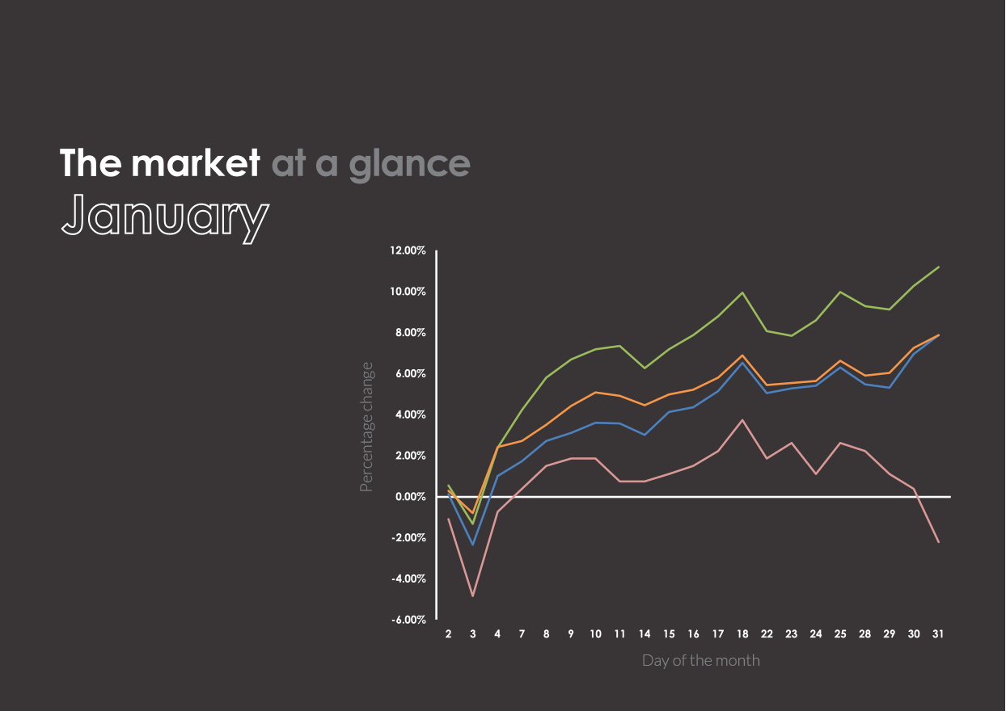




- Hedge fund Elliott Management announced it has taken a $1.4 billion stake in the e-commerce company eBay, which represents four percent of the company’s total shares. Following the announcement,
eBay shares surged as much as 10 percent before finishing with a 6.1 percent gain.
Past performance is no guarantee of future results. Indices are unmanaged and cannot be invested into directly.
U.S. Large Cap
(S&P 500)
2,704.10 (7.87%)
U.S. Mid/Small
(Russell 2000)
1,499.42 (11.19%)
International Large
(NYSE International 100)
5,275.79 (7.88%)
U.S. Treasuries
(U.S. 10-year Treasury yield rate)
2.63 (-2.23)
The market in action
- Just hours before a possible liquidation deal, Sears chairman Edward Lampert added $150 million to
his offer that may keep the department store’s remaining locations open and under his control.
The deal, which still requires approval by a New York bankruptcy judge, would preserve about
400 stores and as many as 50,000 jobs.
- Federal prosecutors unveiled charges for seven individuals stemming from a 2016 international stock-trading scheme that involved hacking into the SEC’s corporate filing database. First discovered in August 2017, the scheme netted $4.1 million.
- The Congressional Budget Office released a report that found the recent government shutdown–the longest in government history–cost the U.S. economy $11 billion. Federal services everywhere from the FBI to national parks had been on hold, leaving 800,000 federal workers without pay since December 22, 2018.

The overlooked costs
of owning an electric vehicle

The hype around electric vehicles continues to grow stronger by the day as more and more consumers are drawn by the allure of cutting-edge designs and dropping the traditional gas tank. According to Inside EVs, U.S. electric vehicle (EV) sales in 2018 grew 81 percent compared to 2017 as over 350,000 consumers became a new owner of a battery-powered automobile.
Still, EV sales remain small when compared to those of traditional gas-powered vehicles and represent under two percent of total automobile sales. If you are considering ditching your traditional car to become an EV owner, be sure to take these commonly overlooked costs into consideration.
Cost per mile is not zero
Yes, owning an EV means you no longer have to worry about gasoline prices, but there is still a
cost associated with each mile you travel.
Compare 2018’s most popular EV, the Tesla Model 3, with the most popular gas-powered vehicle, the Toyota Camry.
According to the U.S. Department of Transportation, Americans drive an average of 13,476 miles per year and the U.S. Energy Information Administration (EIA) estimates the average cost of gasoline in 2019 to be $2.47 per gallon. For the Camry, which averages 35 miles per gallon, this equates to an annual refueling cost of $951.
As for EVs, cost per kilowatt hour (kWh) of electricity becomes the key factor instead of cost per gallon of gasoline. The EIA estimates the average cost of residential energy in 2019 will be about 13 cents per kWh. For the entry-level Model 3 that has a range of 220 miles on its standard 50 kWh battery, this equates to an annual refueling cost of $398.

Although the fuel savings of owning an EV can be substantial, owners often overlook the true cost
of recharging. Know that these savings can vary depending on a number of factors, primarily
your location.
Free public charging is becoming
a thing of the past
Up until recently, public charging was less accessible, but also free for some drivers. Those who purchased a Tesla before 2017 were granted free unlimited access to its network of Supercharging stations, but new Tesla drivers receive a smaller amount before having to pay for the usage. The change comes as Tesla progresses its charging infrastructure to now include more than 10,000 stalls which are within 150 miles of 99 percent of the U.S. population.
Plugincars.com reports that there are nearly 47,000 free public charging stations and about 40,000 paid public stations nationwide as of March 2018. EV shoppers should research their location’s public charging infrastructure and be aware that public charging can cost as much as two to three times compared to charging at home.
Will a base model meet your needs?
As is common with all vehicle sales, electric or otherwise, the final price can increase substantially with additional features. Buyers need to consider whether a base model will meet their needs or if upgrades need to be added.
Again looking at the Tesla Model 3, the entry-level cash price is $42,900 with a 220-mile range battery, but if you are looking to increase to a larger 310-mile range battery, you will need to opt for the $49,900 all-wheel-drive model.

For prospective EV owners who live in remote areas with limited access to public charging, upgrades such as these may be essential.
Government incentives vary widely
Often, the advertised price of an EV takes into consideration savings from government incentives, which can vary from state to state. Owners in all states will receive a federal tax credit of $3,750 for EVs delivered from January 1 to June 30, 2019, but this will be cut down to $1,875 for EVs delivered from July 1 to December 31, 2019.
State and local governments may offer additional incentives for EV owners, and some offer none at all. For example, Colorado provides new EV car buyers with a $5,000 tax credit while Kansas currently has no incentives. These incentives can also vary on a number of factors such as the price of the EV and whether the vehicle is purchased or leased. Be to research and take into consideration your state and local government benefits for the true price.

