
By the numbers
The price of college
September

With classes now underway at most universities, students are starting to dig into their semesters full
of credits. They are also digging into their wallets,
as a report from the Federal Reserve Bank of New York showed that student loan debt is currently the largest chunk of non-housing debt in the U.S., beating out both auto loan debt and credit card debt.
Here is a look at the numbers that showcase the current state of college prices in the United States.
8x
According to a Forbes report citing the Federal Reserve Bank of St. Louis, the median cost of a four-year degree has increased at a rate eight times faster than the rate which median wages have increased. While the cost of a degree has doubled since 1989, wages have only seen a marginal increase.
$27,140
When comparing public and private four-year institutions, private remains a significantly more expensive option.
While the average cost of one year’s tuition, fees, room, and board at a public four-year in-state college is $21,370, this is more than $27,000 less than the average private four-year price of $48,510.
$250
The average published in-state tuition and fees for public four-year schools increased by $250 from last year. This increase brings the U.S. average to over $10,000 for the
first time.
5 percent
Looking at first-time students at public four-year colleges, 78 percent attended a school in the state of which they are a resident. Since 2006, this number has fallen by five percent, showing that more students are opting for an out-of-state education. On average, attending an out-of-state college will cost students $16,060 more
than in-state.
$29,800
Of the 69% of college students from the Class of 2018 that took out student loans, the average student graduated with a debt balance of $29,800.


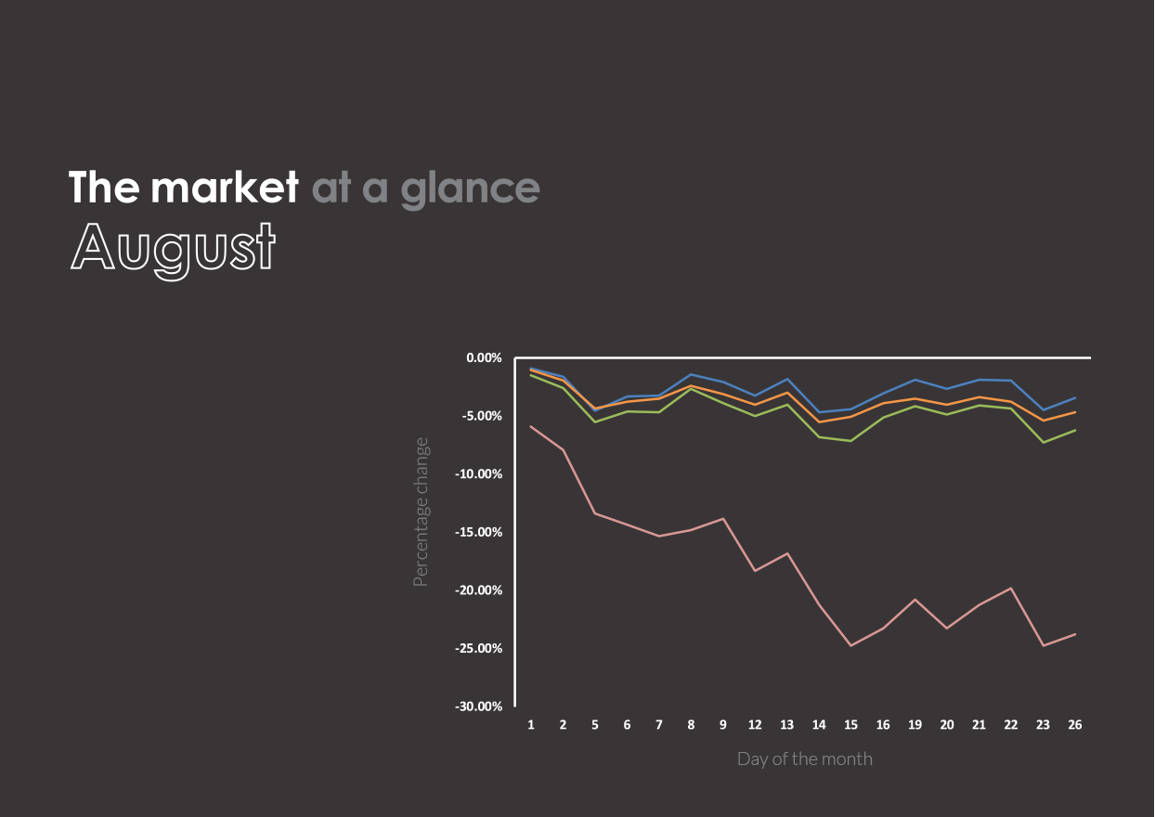


U.S. Large Cap
(S&P 500)
2,926.46 (-1.81%)
U.S. Mid/Small
(Russell 2000)
1,494.84 (-5.07%)
International Large
(NYSE International 100)
5,271.12 (-2.95%)
U.S. Treasuries
(U.S. 10-year Treasury yield rate)
1.50 (-25.74%)
Past performance is no guarantee of future results. Indices are unmanaged and cannot be invested into directly.
The market in action
- Shares of food manufacturer Kraft Heinz fell nearly 20 percent during August following a dip in sales for the 12th straight quarter. As grocery retailers like Walmart, Kroger, and Amazon have increased the production of in-house store brands, the company’s stock has fallen by nearly 40 percent so far this year.
- Financial services and mobile payment company Square broke $1 billion in revenue in the second quarter of 2019, an increase of 44 percent since the same period in 2018. Following the report, Square announced the sale of its meal delivery service to DoorDash for $410 million. Despite the results, higher than projected losses led to a 15 percent dip in share price following the news.
- Luxury department store chain Barneys announced it is filing for bankruptcy and will operate just seven locations moving forward. The closure adds to the more than 7,000 total retail stores that have closed
so far in 2019, a number that is projected to reach up to 12,000 by year-end according to Coresight Research.
- Transportation service company Uber reported its largest quarterly losses ever at $5.24 billion in the second quarter of 2019. Stock-based compensation associated with its IPO in May was a key driver for the losses, though its adjusted revenue has grown at the slowest rate so far in the company’s history. Following the report, shares of Uber were down 10 percent.

The rise of peer-to-peer payments

Ask nearly any of today’s college students how they split the bill for dinner, pay their roommates for cable, or even pay their rent and you will likely hear one common answer: Venmo. Peer-to-peer (P2P) payment services have exploded in popularity leaving many to wonder how bills were ever paid before them. Since just two years ago, P2P payment users have increased by 31.6 million users in the U.S. according to research from eMarketer.
How did this booming industry get started and who are the current big players? Let’s take a look.
eCommerce payments are born
The origins of P2P payments can be traced back to 1998, when Cofinity launched as a financial transaction software company in Silicon Valley by founders Ken Howery, Luke Nosek, Max Levchin, and Peter Thiel. In late 1999, Cofinity would go on to launch its flagship product, PayPal. Noticing the potential of the money transfer business, Elon Musk, now co-founder and CEO of Tesla, facilitated a merger between Cofinity and his X.com business.
PayPal would go on to become the premier way to move money online. A key driver of PayPal’s adoption was its integration with the popular eCommerce platform, eBay. Following its IPO in 2002, PayPal was acquired by eBay for $1.5 billion.
Over the following decade, PayPal would grow to more than 100 million active user accounts spanning 25 different forms of currency.
A forgotten wallet
As PayPal was gaining popularity, Andrew Kortina and Iqram Magdon-Ismail met as freshman roommates at the University of Pennsylvania.
Their bond grew throughout college leading
the two computer science students to work
on several projects together in the years during
and after college.
While attending a local jazz show, the two brainstormed the idea of being able to purchase
a band’s live set by sending a text message that would return an MP3 file via email. It was here that the name Venmo was created, a combination of vendere (Latin for “to sell”) and mobile.
During a weekend working on the music service idea in New York, Magdon-Ismail realized he had forgotten his wallet in Pennsylvania and would pay Kortina back via check for purchases made throughout the weekend. Quickly, the pair realized how inconvenient this solution was and that there was an unsolved need for quick and easy P2P transactions. Though PayPal was convenient for online purchases, its P2P functionality needed to be accessed via a computer. In a world where mobile was quickly emerging as the ideal platform for consumers, Kortina and Magdon-Ismail began pivoted their music purchasing platform to a P2P payment service that users would operate primary through SMS messaging.
The idea quickly appeared to be a hit. The Venmo co-founders would go on to raise $1.2 million of seed funding to develop applications for iPhone and Android users. Following its public launch in March of 2012, Venmo attracted the attention of payment system company Braintree, who would acquire Venmo for $26.2 million just over five months following the launch.
PayPal acquisition and
Venmo today
Venmo continued its explosive growth among money-transferring millennials, but in 2013 its parent company Braintree was looking for a buyer. Coming full circle, PayPal acquired Braintree in late 2013 for $800 million, citing that Venmo was a key motivation to get the deal done.
Today, Venmo has more than 40 million active users that are on pace to transfer more than $85 billion through Venmo throughout 2019. Venmo leads several large banks in terms of digital users, outnumbering Bank of America’s 37 million and Wells Fargo’s 29.8 million. In fact, according to the Wall Street Journal, there is only one U.S. bank with a larger digital footprint than Venmo: JPMorgan Chase with 51 million users.
Venmo has also dipped into the physical payments industry with its Venmo card that allows users to use their Venmo balance by swiping a MasterCard-network enabled debit card at registers.
Cash App
Cash App is a competitor to Venmo that is
owned by financial services company Square Inc. The service was created after Square fell short to PayPal in the acquisition talks with Braintree. The service operates with great similarity to Venmo in that users with the mobile app can send and receive payments to peers. It also offers a physical card, the Cash Card, for users to spend their balance at retail locations. To help compete with Venmo’s card, the Cash Card offers promotional discounts called “Boosts” that give a certain percent or dollar off at specific retail chains
or categories.
Despite doubling its number of active user
accounts from 2017, Cash App entered 2019
with just 15 million users compared to Venmo’s current 40 million.
Zelle
Big banks have certainly taken notice of the demand for easy P2P payments and in 2017 launched Zelle. The service is run by Early
Warning Services, which itself is owned by
Bank of America, BB&T, Capital One, JPMorgan Chase, PNC Bank, US Bank, Citibank, and Wells Fargo. With tight integration through these bank owners, Zelle places transferred money right into a user’s bank account, not a separate balance like Venmo and the Cash App. Additionally, Zelle does not require users to set up an account if they are members at one of many participating banks.
Zelle has mounted a significant challenge in the
P2P payments race and passed Venmo in terms of volume of transactions in July of 2018. Looking at the entire year, Zelle nearly doubled Venmo’s total transaction volume.

Though one would be quick to say Zelle is winning the P2P payments battle, adoption remains lower than Venmo across every generation. Forbes notes that a key driver in the difference regarding transaction volume could be that Zelle is used by older generations as a more traditional bank transfer for items such as alimony payments.

